ORGANIC TOPIC TEST 3. 2015
/53
NAME: ____________________________________

SECTION ONE (10 MARKS)

Circle the most correct answer for each question. This section is worth 10 marks.

- Which of the following are isomers of each other?

I. methyl propanoate
II. 1-propyl methanoate
III. 2-propyl methanoate
IV. butanoic acid

A. II and III
B. I, II and III
C. I and IV
D. all of them

- Cyclopentanol can be oxidised by acidified potassium dichromate solution to form

A. cyclopentanoic acid
B. cyclopentanal
C. cyclopentanone
D. cyclopentanol is resistant to oxidation

- Which of the following statements about benzene is false?

A. It is more reactive than ethene
B. The shape around each carbon atom is trigonal planar
C. It predominantly undergoes substitution reactions rather than addition reactions
D. All the bonds between carbon atoms are the same length and of the same strength

- Which of the following has an empirical formula different to the other three substances?

A. glucose, C₆H₁₂O₆
B. ethanoic acid
C. methyl ethanoate
D. methanal

Questions 5 and 6 refer to the following six substances

I | 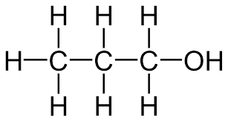 |  | IV | 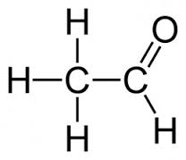
II | 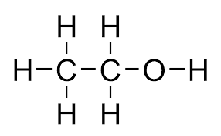 |  | V | 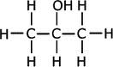
III | 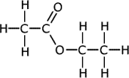 |  | VI | 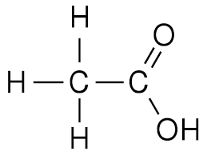

- Which of the following can be oxidised by acidified potassium permanganate?

A. I and II
B. I, II and III
C. I, II, IV and V
D. IV only

- Which pair of substances does not represent an ester?

A. the main product of reaction between I and VI
B. the main product of reaction between V and VI
C. the main product of reaction between IV and VI
D. III

- Which of the following could undergo an addition reaction with hydrogen bromide to form 2-bromobutane?

I. but-1-ene
II. cis-but-2-ene
III. trans-but-2-ene
IV. butane

A. I and IV
B. II and III
C. I, II and III
D. all of them

- Which of the following best describes a soap?

A. An ionic salt of a long-chain carboxylic acid.
B. A glycerol triester.
C. A substance that does not form a scum in hard water.
D. An unsaturated ester.

- Which of the following could be considered an addition reaction?

A. The reaction between methane and bromine.
B. The polymerization of ethene.
C. The reaction between benzene and bromine .
D. Esterification between methanol and methanoic acid

- Consider serine

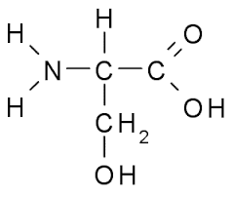

Which of the below correctly identifies the three functional groups in serine

A. amide, primary alcohol and carboxylic aci
B. secondary alcohol, amine and carboxylic acid
C. amine, primary alcohol and ketone
D. amine, primary alcohol and carboxylic acid

SECTION TWO (43 marks)

11. Name and draw full structural formula to represent the following substances;

The product of reacting methanol with an excess of acidified potassium dichromate | Name …………………………………………
An isomer of propanal that is resistant to oxidation | Name …………………………………………
A cyclic isomer of methylpropene | Name …………………………………………
The organic product of reacting 1 mole of benzene with 1 mole of bromine | Name …………………………………………
A tertiary alcohol which is a structural isomer of butan-1-ol | Name…………………………………………
The ester with the fewest carbon atoms | Name ……no name needed……………

(11 marks)

12. The molecule below is called a dipeptide and is formed by the reaction between two amino acids
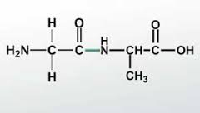
In the boxes below , draw the structures of the two amino acids from which this dipeptide was made.

(3 marks)

13. Propene is an alkene from which the polymer poly(propene) can be produced.

In the box below, draw three repeating units of poly(propene)

(3 marks)

14. The diagram below shows the structure of lactic acid.

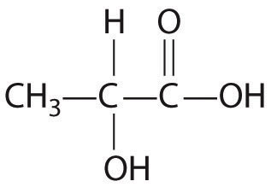

In the space below, draw the product of condensation polymerisaton of three lactic acid molecules
(3 marks)

15. ‘Kevlar’ is a polymer used in bullet-proof clothing and Formula One car tyres. The diagram below shows two parallel polymer chains

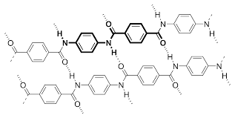

(i) To what class of polymer does ‘Kevlar’ belong?

………………………….

(ii) What do the dotted lines on the diagram represent?

………………………….

(iii) In the box below, draw the full structures of the monomer(s) from which Kevlar is made?

(1+1+2=4 marks)

16, In the space below, indicate how you could differentiate between the following pairs of substances, detailing the chemical you would use and the observation that you would expect for each substance.

Pair of substances | Test | Observations
propanone and  propanoic acid |  | propanone
 |  | propanoic acid
benzene and cyclohexene |  | benzene
 |  | cyclohexene

(6 marks)

17. The following five structures each represent one of the following

A, An unsaturated fatty acid
B. A saturated fatty acid
C. A glycerol triester
D. A soap
E. Glycerol (propan-1,2,3-triol)
F. A detergent

Identify each structure by placing the correct letter in the boxes provided

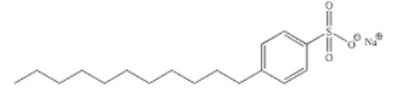

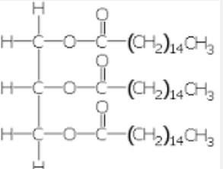

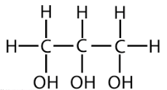

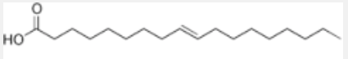

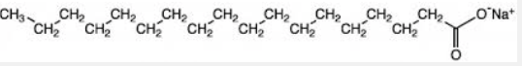

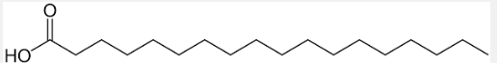

(6 marks)
18. The structures of three organic molecules are shown below.

In the boxes below, indicate your predicted order of the melting points of these substances. Then fully explain the reasons for your choice in the space below.

Name | Structure | Approximate  Molar Mass | Order of melting point  (1=highest, 3=lowest)
Ethandioic acid  (oxalic acid) | 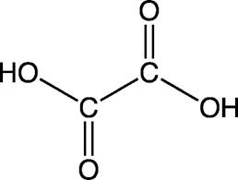 | 90
Butanoic acid | 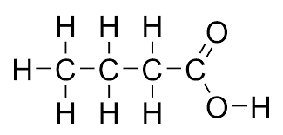 | 88
Alanine | 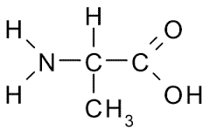 | 89

(2 marks)
Explanation.

…………………………………………………………………………………………………

…………………………………………………………………………………………………

…………………………………………………………………………………………………

…………………………………………………………………………………………………

…………………………………………………………………………………………………

…………………………………………………………………………………………………

…………………………………………………………………………………………………

…………………………………………………………………………………………………

…………………………………………………………………………………………………

…………………………………………………………………………………………………

…………………………………………………………………………………………………

(5 marks)

END OF TEST

